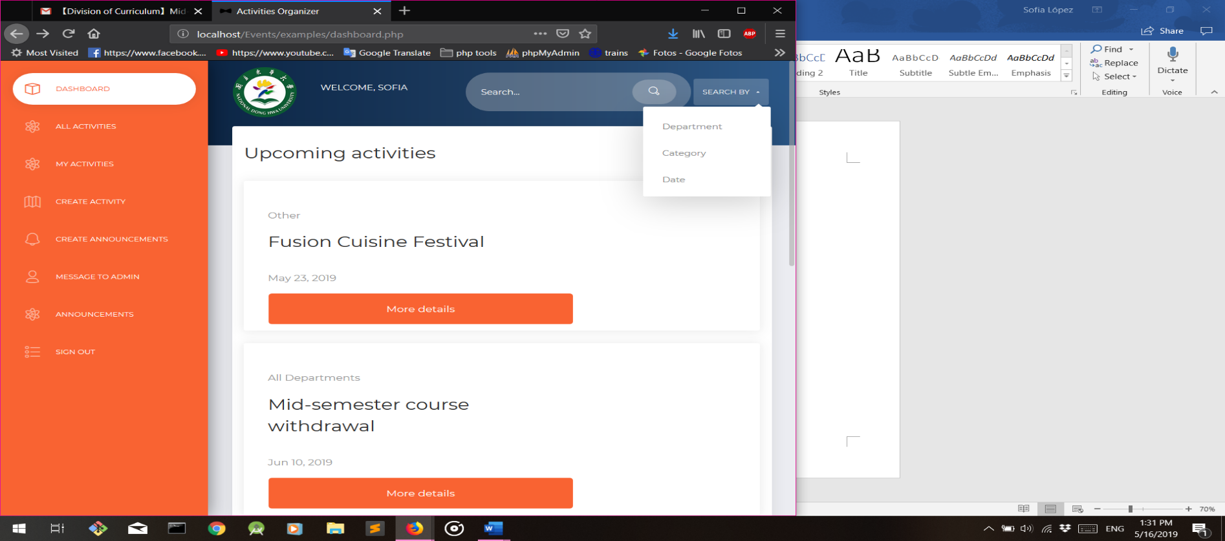

|  |  |  |  |  |  |  |  |
| --- | --- | --- | --- | --- | --- | --- | --- |
| **What’s NDHU Events?**  It’s a centralized website that offers all the information regarding activities happening in NDHU.  **Why should I join?**  Stop missing all the good or important events near you! In this site you can see all the future and past activities with all their details as well as show your interest indicating whether you would like to attend or not or you can even become part of the staff if the activity requires it.  **Who can join?**  Any NDHU student, staff or can be a part of it, you just need your NDHU email to register. | |  | | --- | | **NDHU Events Page**  All the information about activities happening on campus in one place.  Don’t’ miss anything and join us to be updated with all coming events!!! |  |  |  |  |  |  | | --- | --- | --- | --- | --- | |  |  |  |  |  | |

Team members:

*Sofia Lopez

*Andres Obregon

Advisor:

*Professor Lai